RECIPE  
No-Bake Chocolate Drops

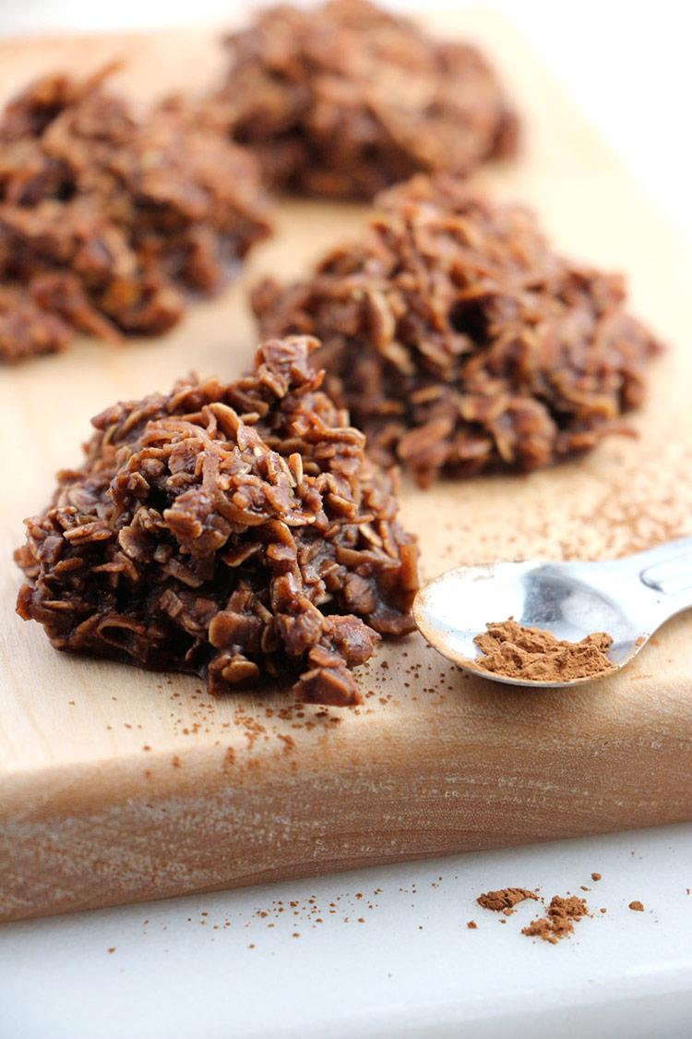

# Ingredients

* 1 ½ cups white sugar
* ¼ cup butter
* ½ cup milk
* ½ cup cocoa
* ½ cup peanut butter
* 1 cup coconut
* 3 ½ cups oatmeal
* 2 tsp vanilla

# Preparation

1. Combine white sugar, milk , butter, and cocoa powder
2. Boil together for 2 minutes
3. Take off and add peanut butter, coconut, oatmeal, and vanilla.